**PRACTICAL ACTIVITY 3: ON LINUX SYSTEM ADMINSTRATION**

**Part 1: of Practical Activity Week 3**

List the processes for the current shell.

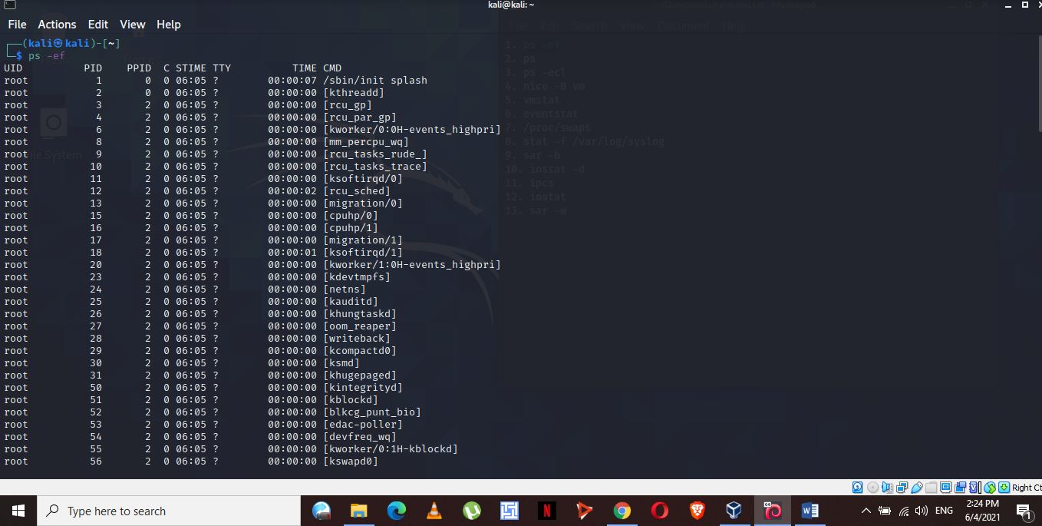

Display information about processes.

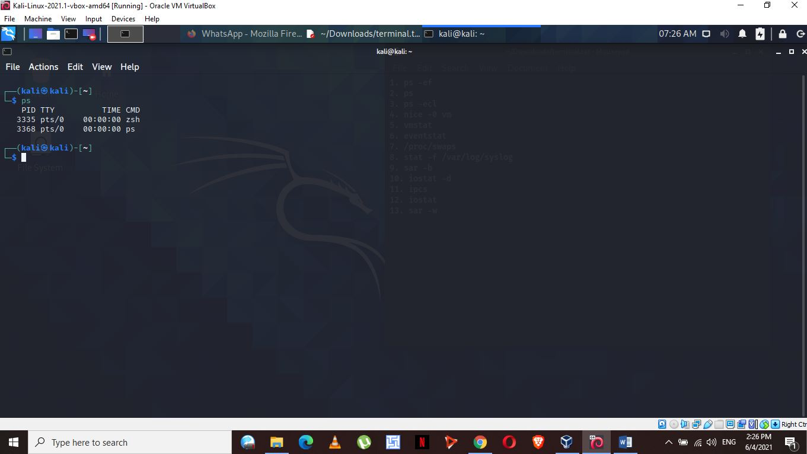

Display the global priority of a process and find out the column that provides.

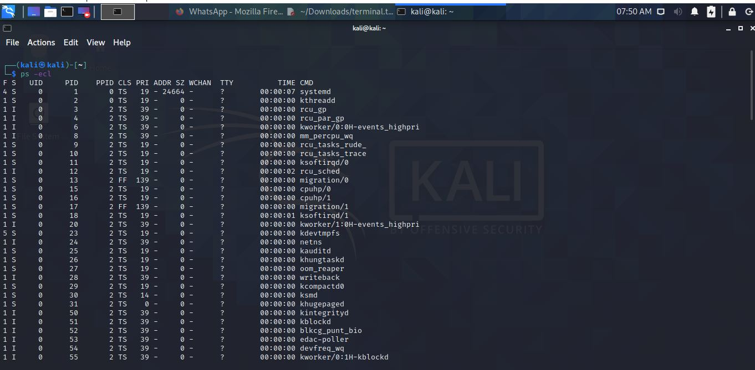

Change the priority of a process with default arguments.

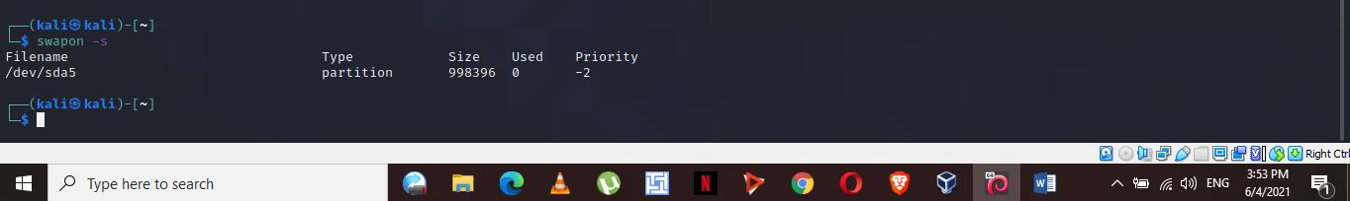

Display Virtual Memory Statistics.

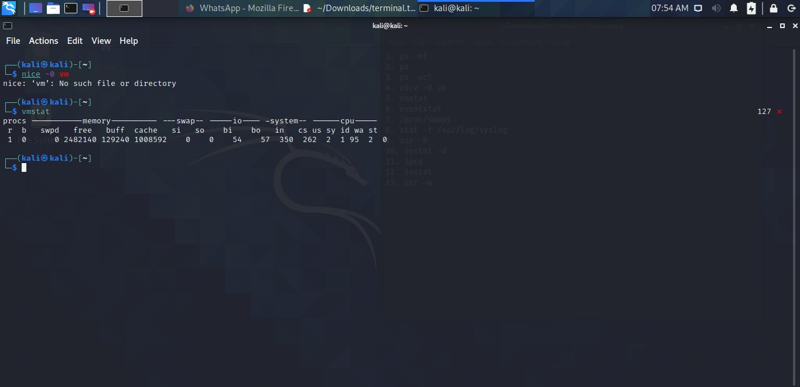

Display System Event Information

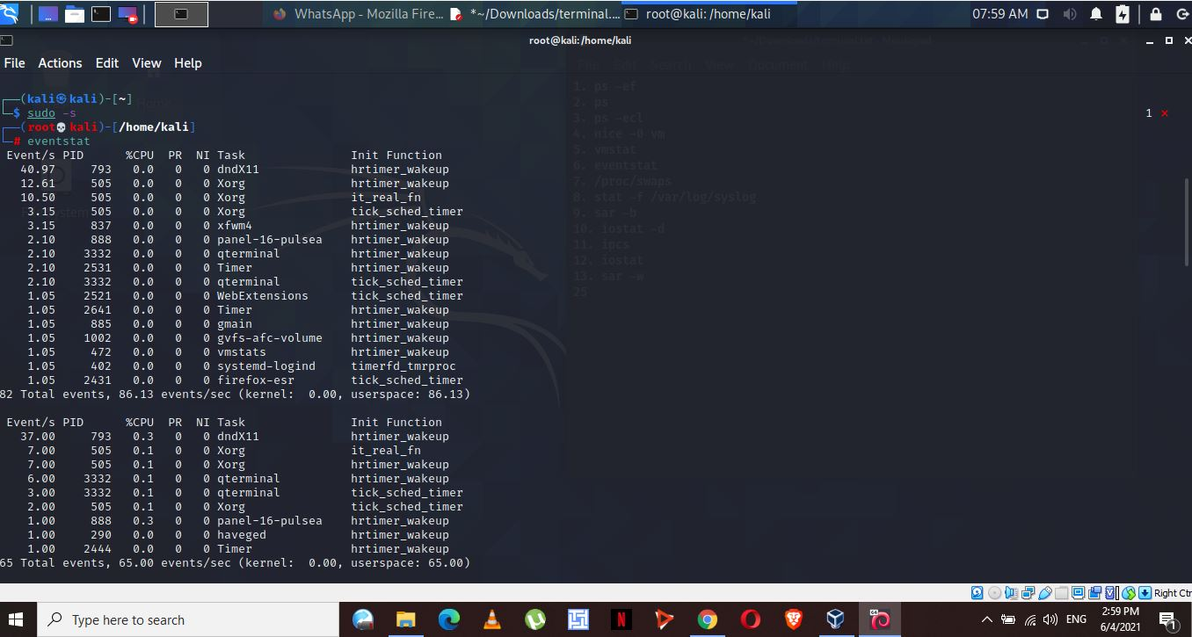

Display Swapping Statistics.

Check File Access statistics.

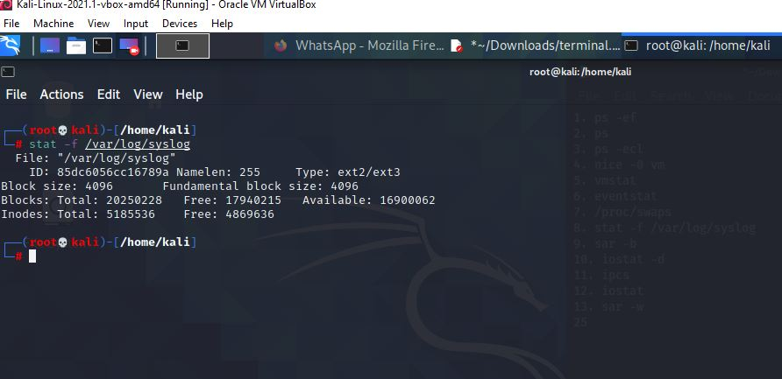

Check Buffer Activity statistics.

Check Disk Activity statistics.

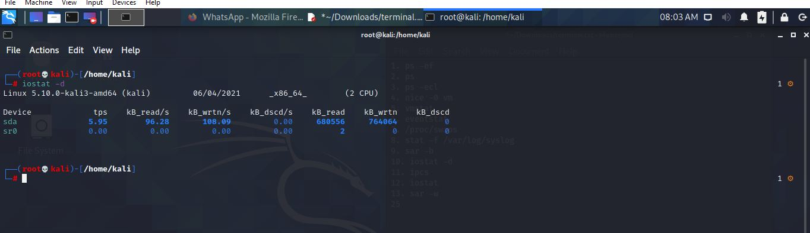

Check Inter process Communication statistics.

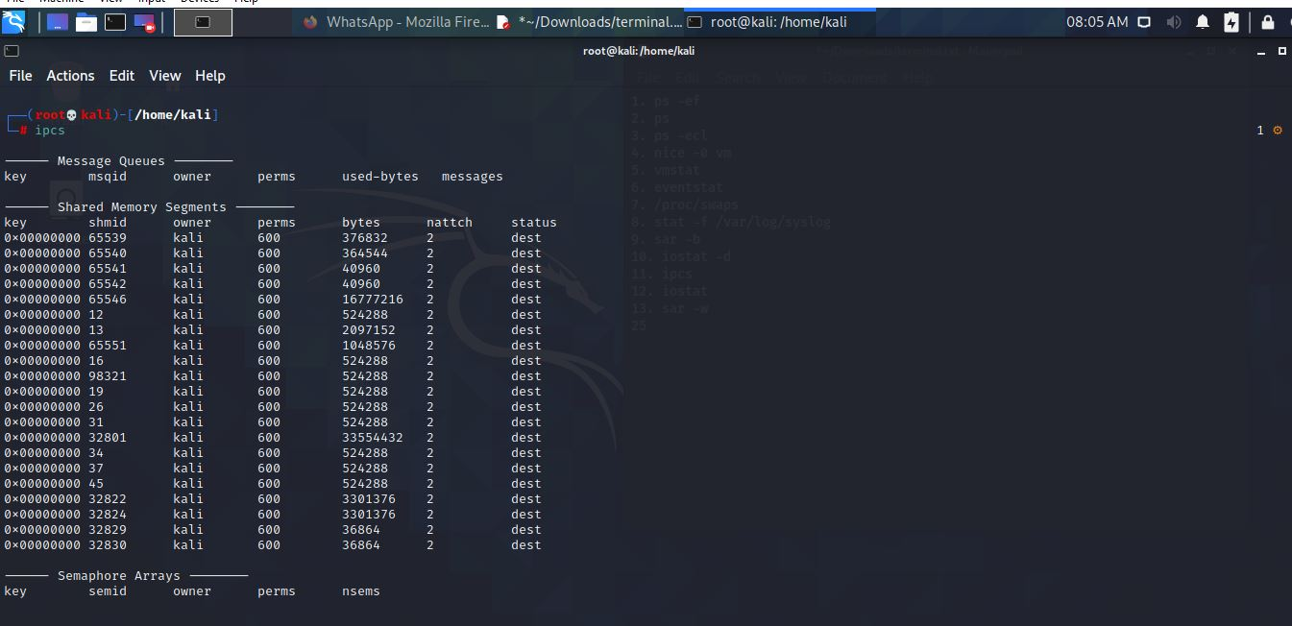

Check Unused Memory in the server.

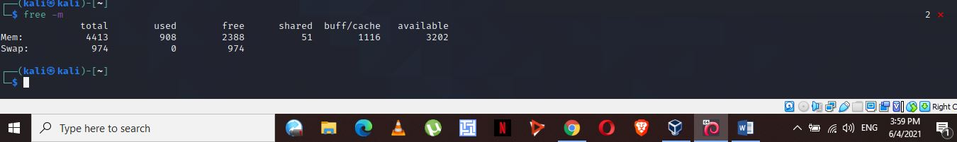

Check Swap Activities.

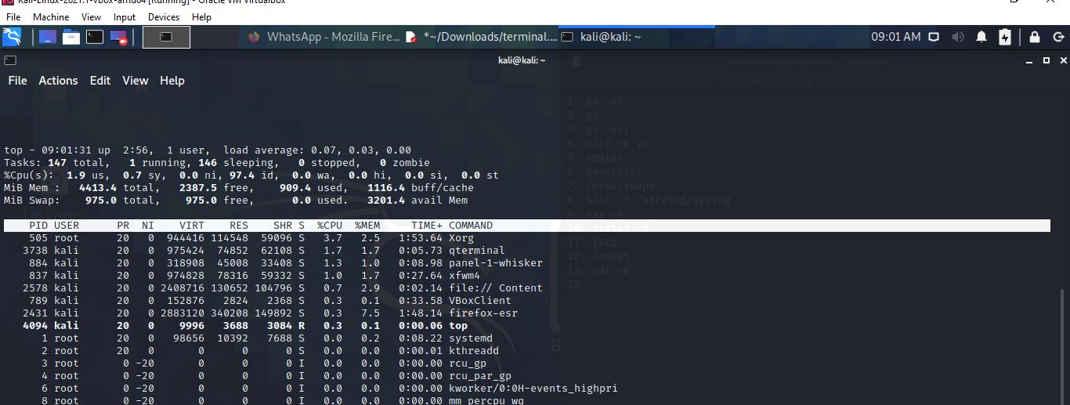

**Part 2 : Practical Activity Week 3**

Login to your terminal in Ubuntu.

Create a user account called user1 and another user2

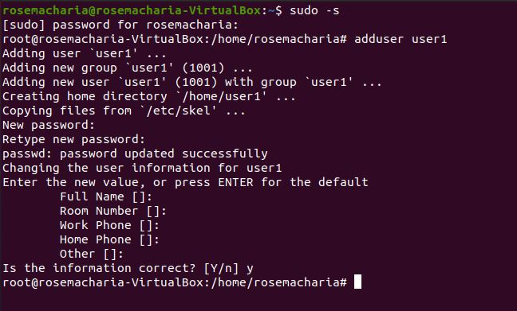

Ensure user1 and user2 are password protected.

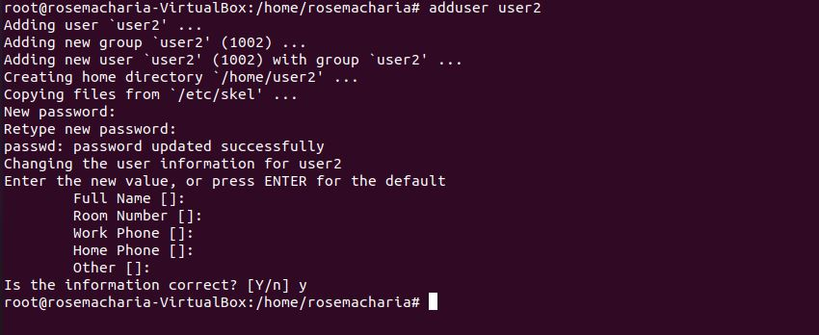

Logout and login as user1

Create a testdir

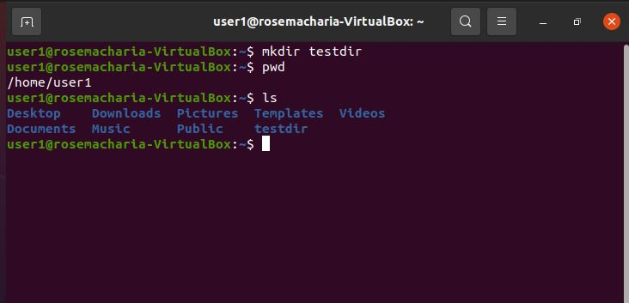

Create a file testfile in testdir

Verify the ownership and the group of the testfile

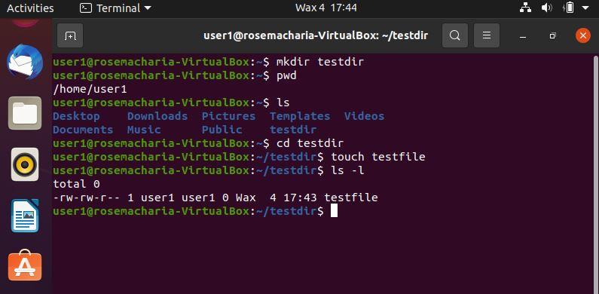

Switch to Superuser account

Create a public directory dir1

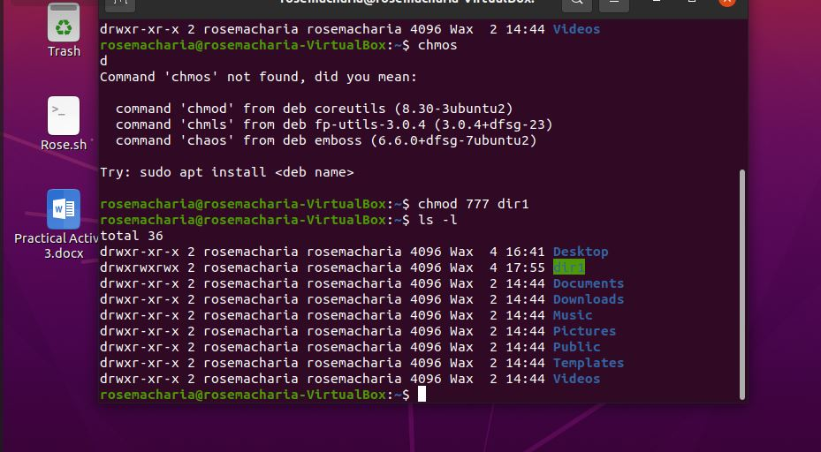

Set stickybit (save text attribute) on dir1

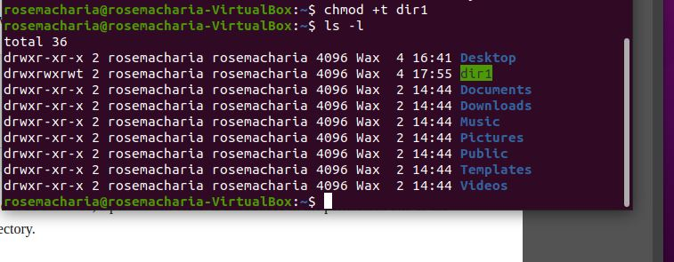

Logout and login as a normal user user1

Create a file userfile1 in dir1

